
CSA16-DATA WAREHOURSE AND DATA MINING
Lab Exercise
1.List of Programs:
1The intervals and corresponding frequencies are as follows. age frequency 1-5. 200
5-15 450
15-20 300
20-50 1500
50-80 700
80-110 44
Compute an approximate median value for the data

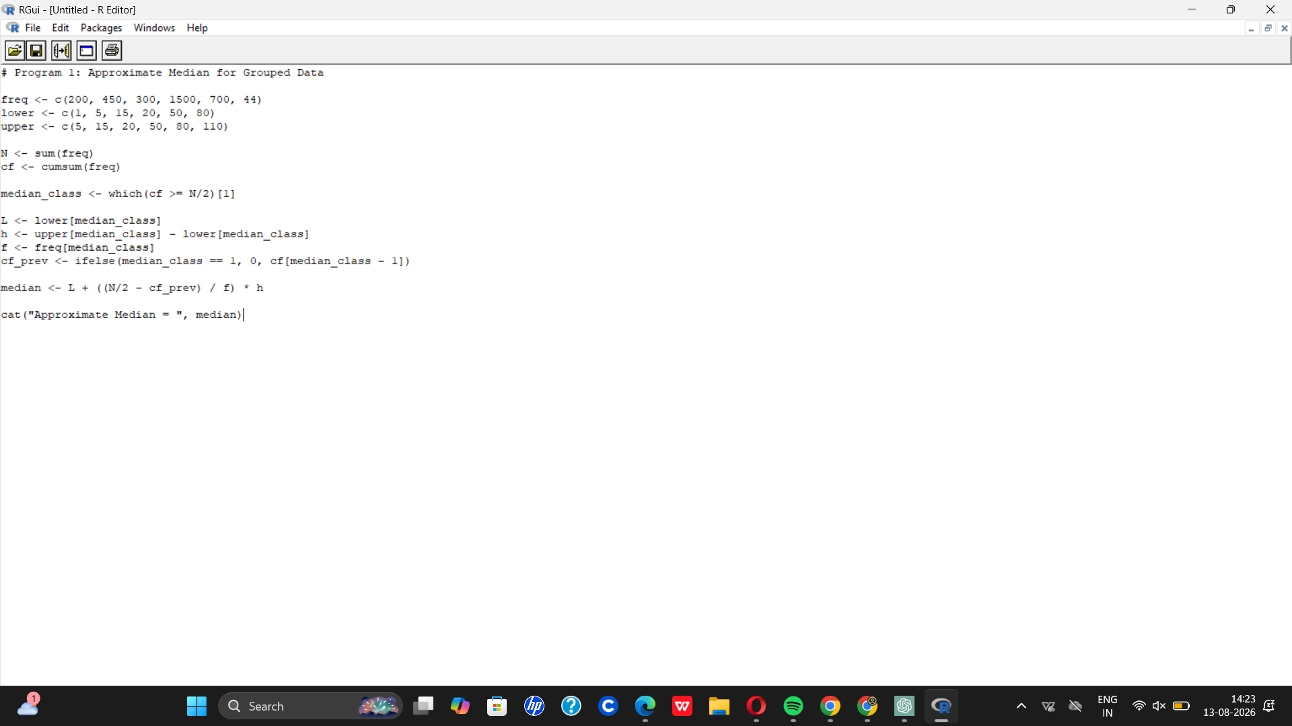
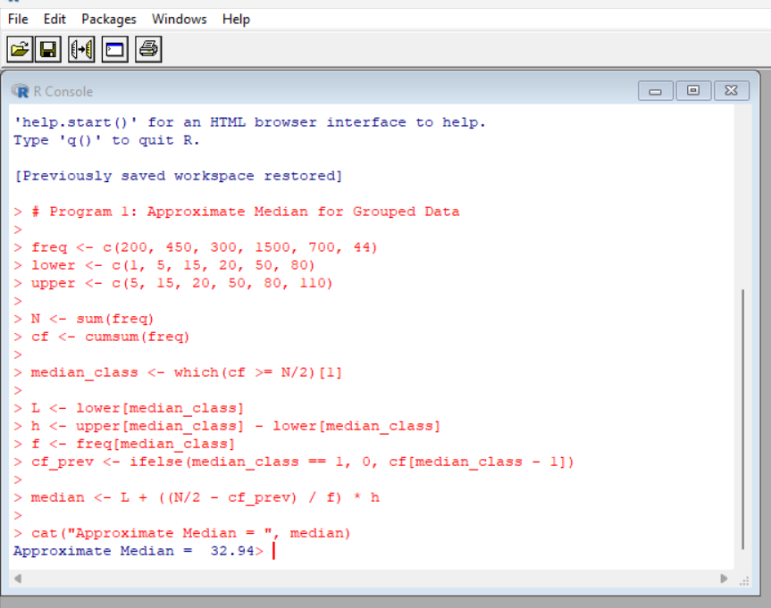
- Suppose that the data for analysis includes the attribute age. The age values for the data tuples are (in increasing order) 13, 15, 16, 16, 19, 20, 20, 21, 22, 22, 25, 25, 25, 25, 30, 33,
33, 35, 35, 35, 35, 36, 40, 45, 46, 52, 70.
  - What is the mean of the data? What is the median?
  - What is the mode of the data? Comment on the data’s modality (i.e., bimodal, trimodal, etc.).
  - What is the midrange of the data?
  - Can you find (roughly) the first quartile (Q1) and the third quartile (Q3) of the data?
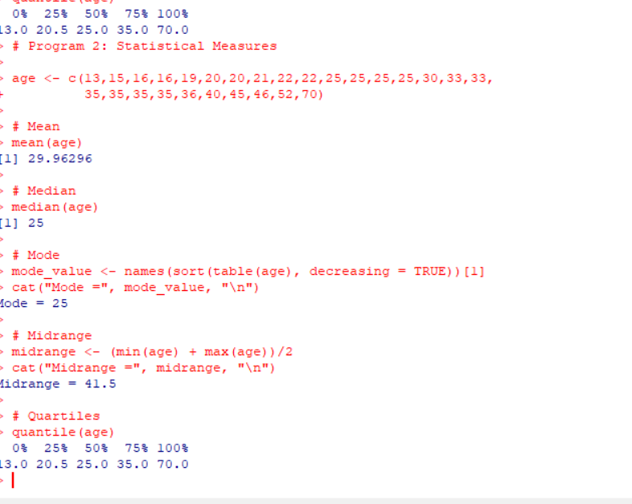
- Data Preprocessing :Reduction and Transformation
Use the two methods below to normalize the following group of data: 200, 300, 400, 600, 1000 (a) min-max normalization by setting min = 0 and max = 1 (b) z-score normalization
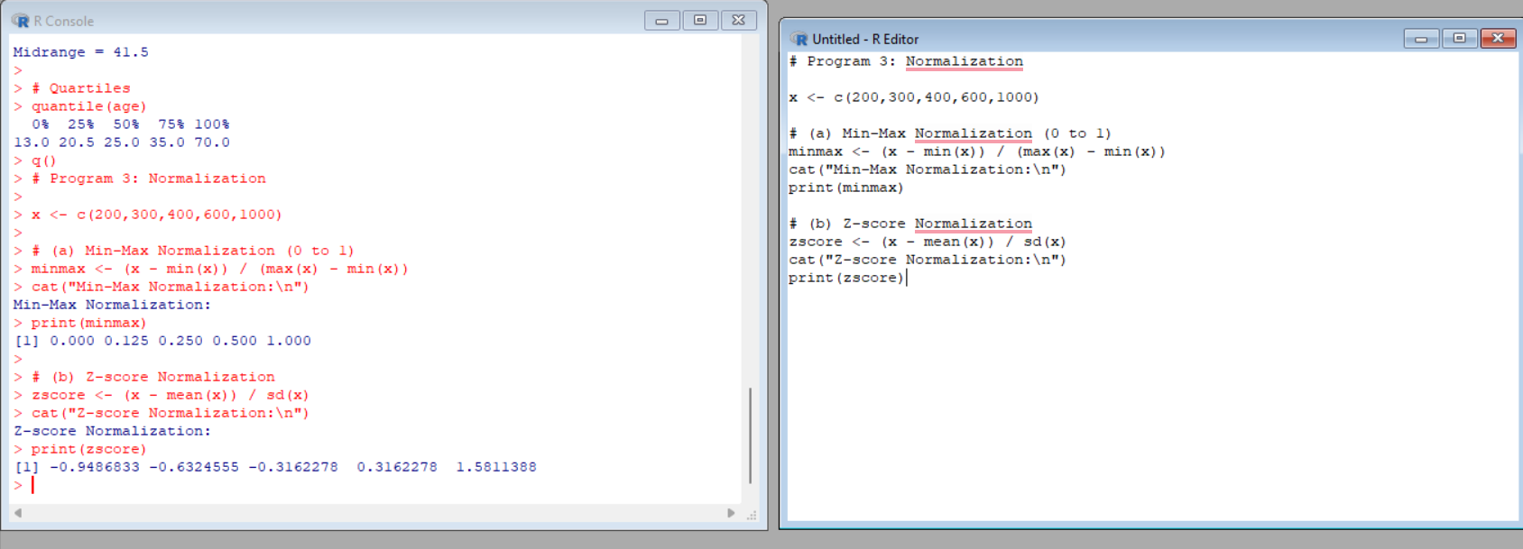
- Data:11,13,13,15,15,16,19,20,20,20,21,21,22,23,24,30,40,45,45,45,71,
72,73,75

- Smoothing by bin mean
- Smoothing by bin median
- Smoothing by bin boundaries
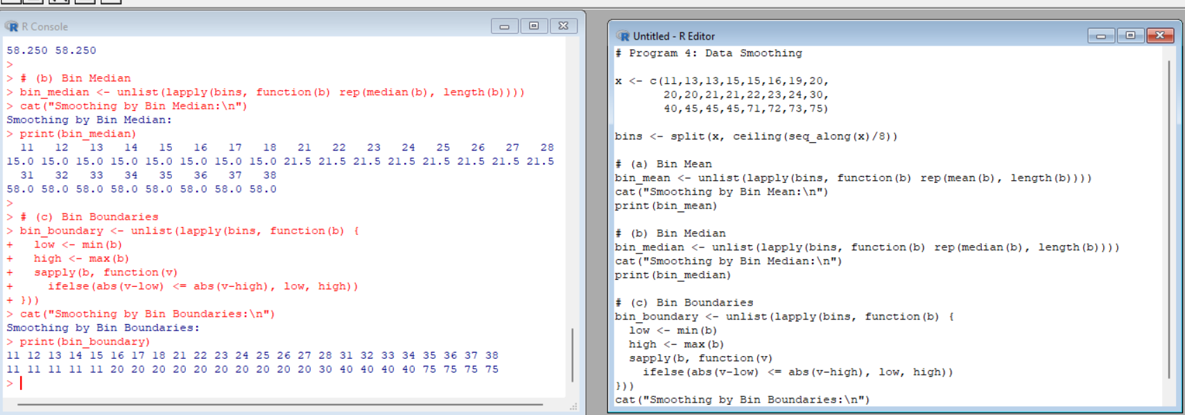
- Suppose that a hospital tested the age and body fat data for 18 randomly selected adults with the following results:
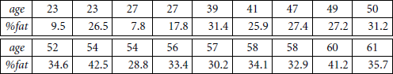

  - Calculate the mean, median, and standard deviation of age and %fat. (b) Draw the boxplots for age and %fat.
  - Draw a scatter plot and a q-q plot based on these two variables.

  - 
   